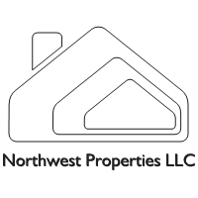

Northwest Properties Property Take Over List

Here is a short list of things that we will need in order to take over the property management duties for your property.

1. Your current mailing address, phone numbers, and email address. Checking account # and routing number if you would like EFT transfers directly to your bank account.
2. The renters file for the property that has all current information on the people living at the address.
3. A copy of the rental agreement that the current tenant is living under.
4. Condo or Home Owners Association Information if applicable.
5. A copy of the insurance policy with most recent declaration and payment information if you would like us to set up an escrow for the insurance and taxes.
6. A copy of the mortgage statement if you would like us to handle the mortgage payments for you.
7. A copy of any governmental licenses or permits required by the city were the property is located.
8. A copy of any service agreement or contract associated with the property.
9. A copy of all the utility bills that are associated with the properties that you would like us to handle.